# CS 340 README Project Two

## Project Two

The purpose of this project is to create a robust, web-based dashboard for an animal shelter company, leveraging MongoDB and Python tools to enhance operational efficiency and effectiveness. This dashboard will serve as a centralized platform for managing and monitoring various aspects of the shelter's operations, including animal intake, adoption processes, medical records, and volunteer coordination. The goal is to streamline processes, improve transparency, and ultimately enhance the care and adoption experience for animals in need.

**Installation**

*Python 3.6*

*Pymongo 4.2*

*MongoDB 4.2*

*Data available in a Mongo database collection, see example on importing a CSV*

*Dash Leaflet*

*Plotly Dash*

**Product Walkthrough**

Grazioso Salvare requested the dashboard to have a few key components:

* Branding with logo
* A link to their website
* A data table, with custom filters, containing the information about the animals at the Austin Animal Shelter
* Custom filters provide targeted animals for specific business needs.
* A map with the location of a selected animal

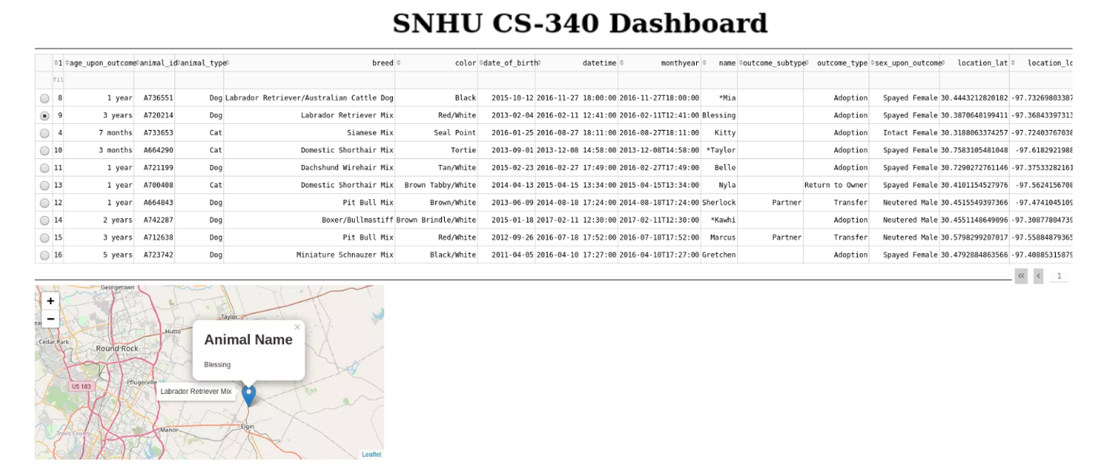

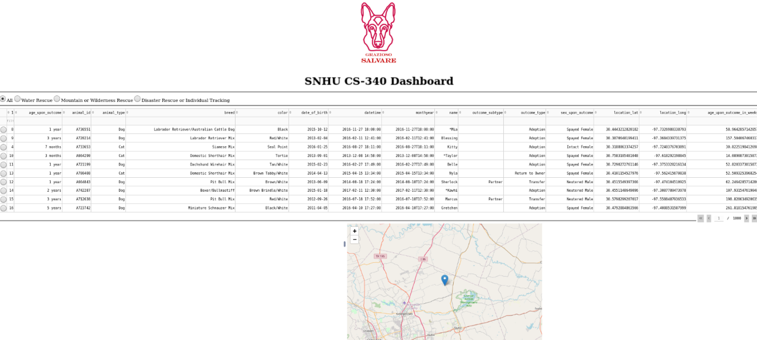

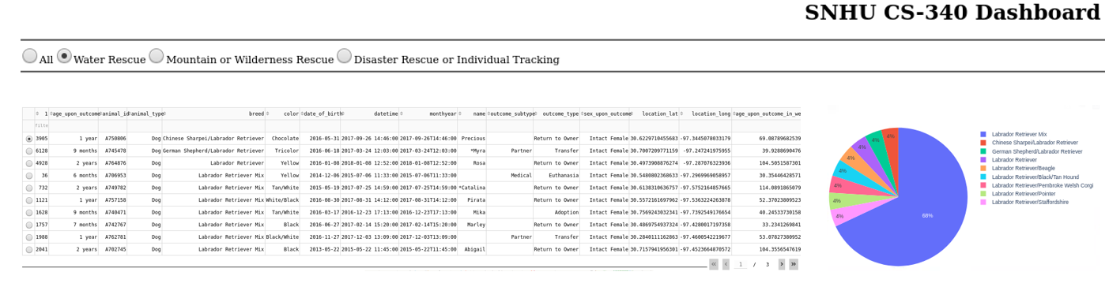

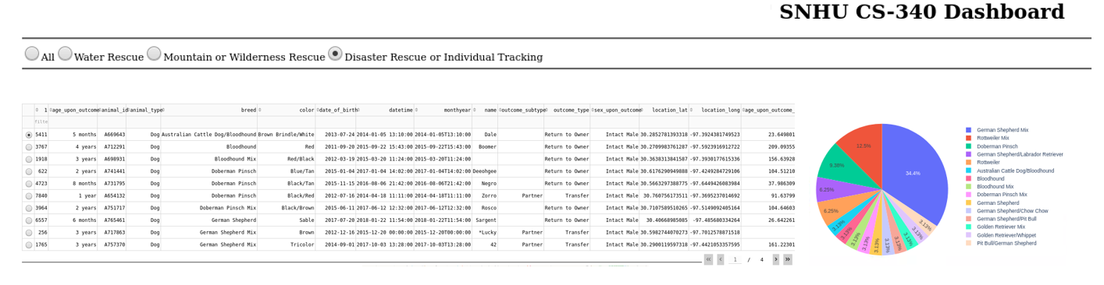

### Project Setup

Data Import:

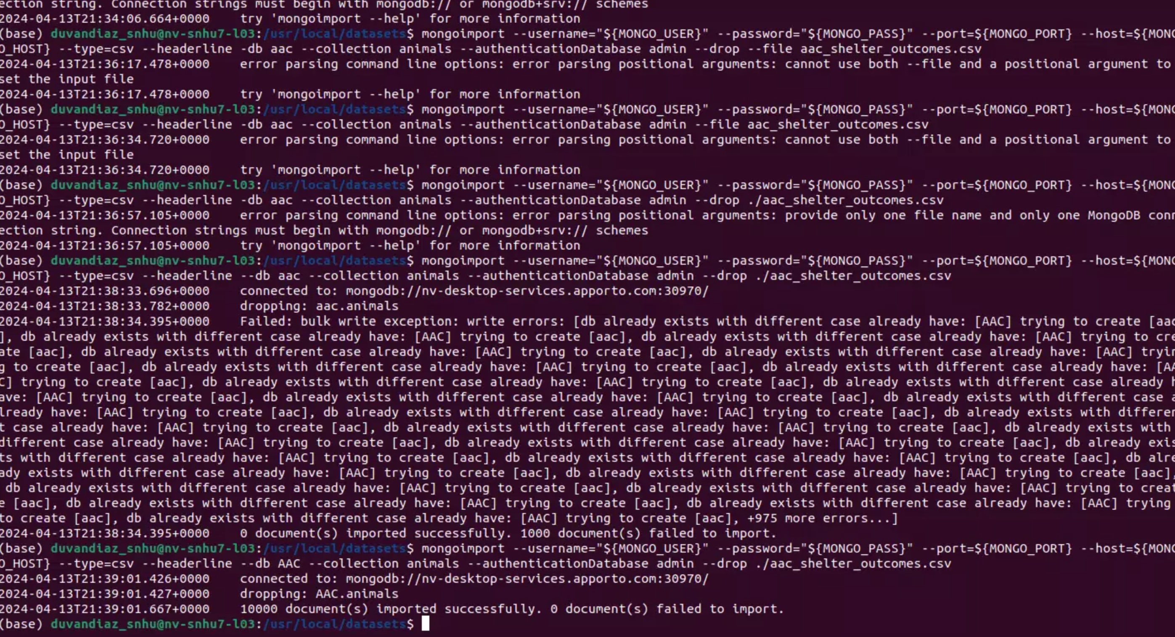

Create User:

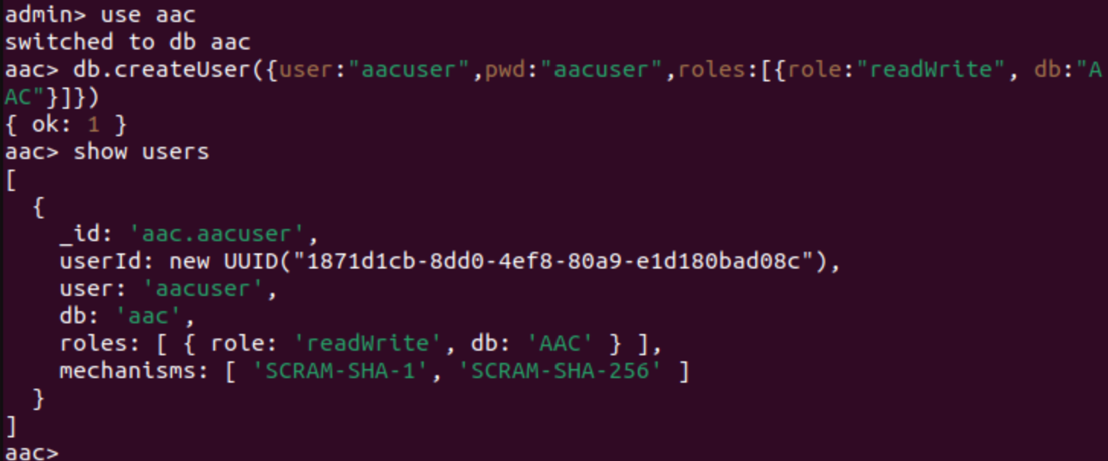

CRUD:

* **A Create method that inserts a document into a specified MongoDB database and collection**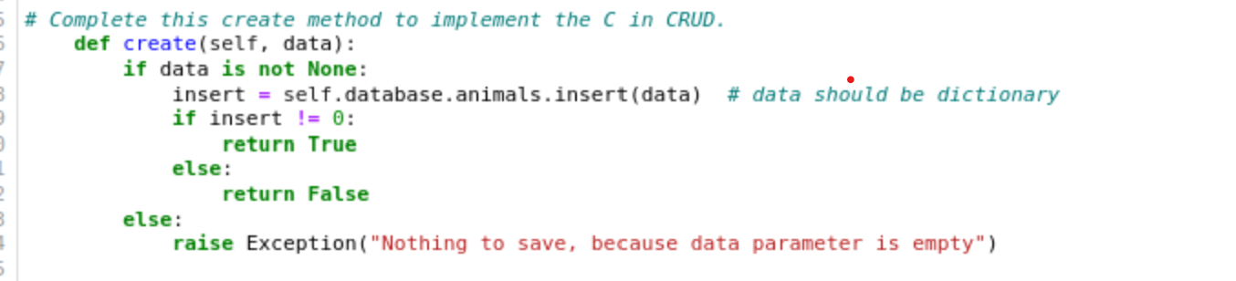
* **A Read method that queries for document(s) from a specified MongoDB database and specified collection** 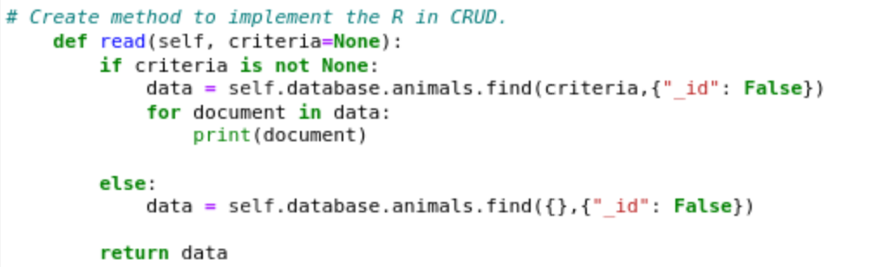
* **An Update method that queries for and changes document(s) from a specified MongoDB database and specified collection** 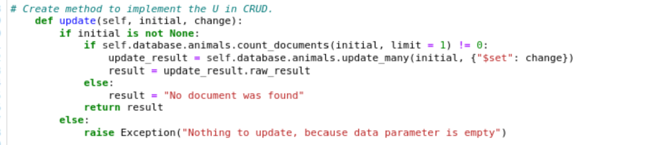
* **A Delete method that queries for and removes document(s) from a specified MongoDB database and specified collection** 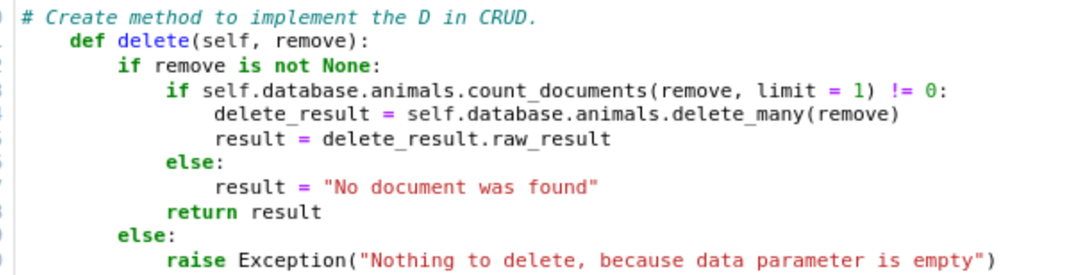

New entry creation with boolean outcome:

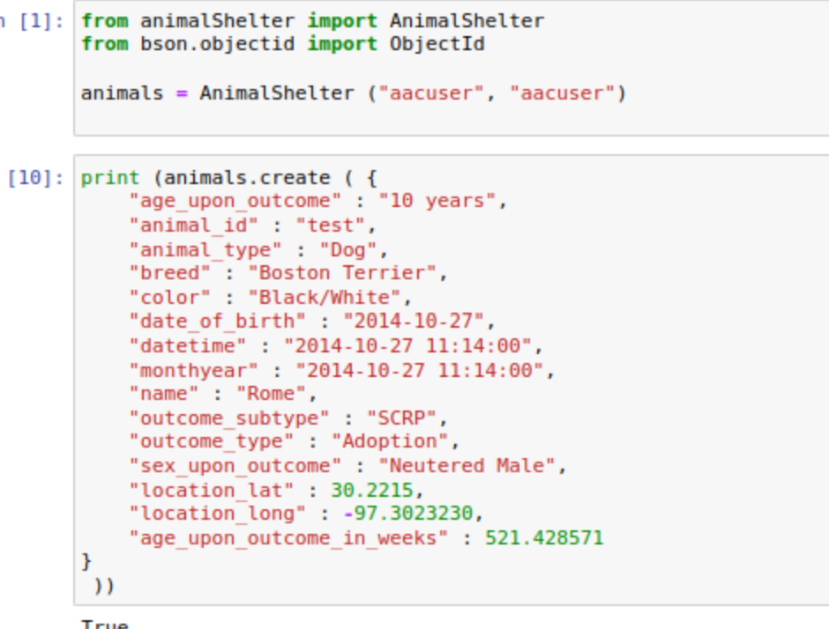

Animal Documentation update:

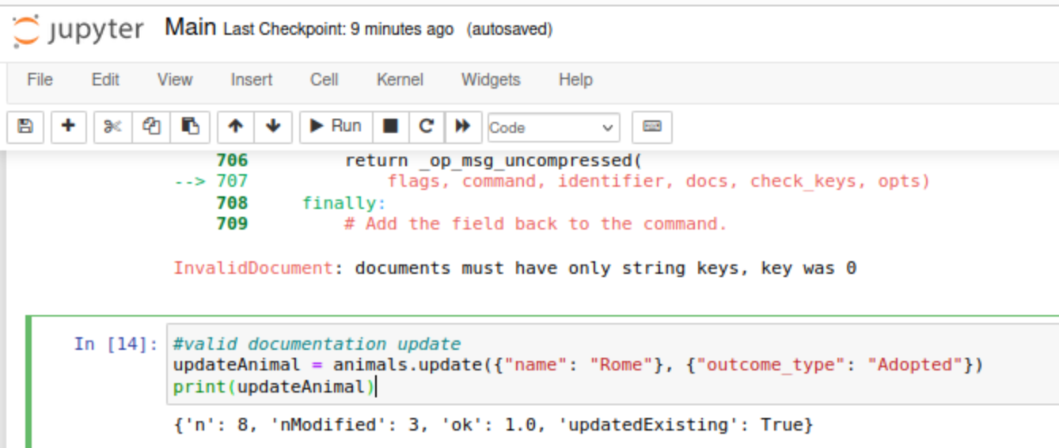

Filters example:

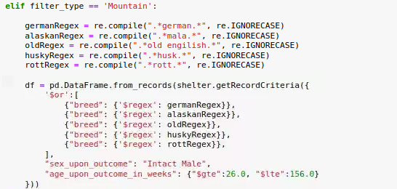

Company’s logo and link:

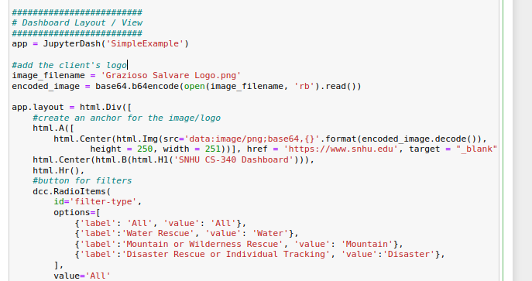

## Challenges

I kept encountering errors with plotly dash, for some reason it kept saying module was non-existent and when I would try to install (pip install plotly==5.22.0) it would say module was already installed, so I had to restart my work and try again. Additionally, company’s logo would take so long to load. Abbreviations in the data also caused some confusion to be able to accommodate client’s business requirements.

## Contact

Duvan Diaz

Duvan.diaz@snhu.edu